Description: Be clear and descriptive and use appropriate and well-explained medical terminology.
It is an inherited condition characterized by an X chromosome that is abnormally susceptible to damage, esp. by folic acid deficiency
There are a range of problems including learning disabilities and cognitive impairment. Most males have mild to moderate intellectual development, about one third of females have intellectual disabilities.
Children with Fragile X Syndrome may have anxiety or ADD, some have issues related to autism in communication and social interaction. Seizures occur within 15% of males and 5% of females.
Most males and about half of females with fragile X syndrome have characteristic physical features that become more apparent with age. These features include a long and narrow face, large ears, a prominent jaw and forehead, unusually flexible fingers, flat feet, and in males, enlarged testicles (macroorchidism) after puberty.

Fragile X is caused by a mutation in the X chromosome, where there is a flaw in the FMR1 gene. This gene holds the fragile x mental retardation 1 protein, which is critical for the coding of synapses. Synapses are part of nerve cells, critical to relaying messages from nerve to nerve.
Normally a CCG segment of DNA in the FMR1 gene is repeated 5 to 40 times, but in the case of fragile X, it is repeated about over 200 times. When the gene is repeated this much, it cancels out the job that it was meant to do, and therefore the gene is ineffective. The normal structural functions of the brain cannot operate properly.
This means that women with the premutation have an increased risk of having a child with fragile X syndrome. Men pass the premutation only to their daughters. Their sons receive a Y chromosome, which does not include the FMR1 gene.

A pedigree showing inheritance or a karyotype of the disorder as applicable to the case. Make sure to explain to the family what this diagram tells them about the likelihood of disease.
The following is a karyotype of a fragile X male
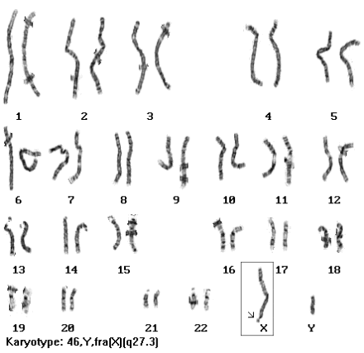

A list of at least three questions the couple or patient is most likely going to ask you about the situation. Provide a brief response to each question using a different color pen or text.
How likely is it that we will have another child with Fragile X Syndrome?
Fragile X is passed from parents who have the premutation, 55 to 200 repeats of CCG, and therefore their children may have an increase in the gene which would cause the symptoms of Fragile X. Fragile X syndrome occurs in approximately 1 in 4,000 males and 1 in 8,000 females. Individuals with more than 200 repeats have a full mutation.
Can my son have a normal life?
Children often have no medical complications based on their diagnosis, and live normal life spans. They are susceptible to ear infections, and may need tubes in their ears.
Symptom severity varies greatly from child to child, so there is no guaranteed yes or no to the question of how normal can the child function. He could lead a fully normal life, or a very handicapped one. It is all about accepting the new “normal.”
Will others in my family have a child with Fragile X Syndrome?
A woman with a full mutation has a 50-percent chance of passing it to her baby in each pregnancy. Men with a full mutation generally do not reproduce. Men can only pass their faulty gene to their daughters because boys do not receive the X chromosome from their fathers.

Provide recommendations to the patient or family. Make sure to reference their personal situation and to provide options. Refer to the available types of genetic testing that are applicable to the case. Your job is to help the patient or family understand their risks and their reproductive options and to discuss options for testing, treatment, or living with this disease. Be sure to discuss potential ethical or moral issues associated with genetic testing and screening. Your recommendations should help the parents or the patient make well-informed decisions related to his or her own health and the health of their offspring.
The Southern blot analysis test determines if the gene has a full mutation, its approximate size, whether the gene has been “methylated” and if there is mosaicism of the gene (a mixture of different cell types). The polymerase chain reaction (PCR) analysis can determine the actual number of “CGG repeats” (a pattern of DNA) that are present in the Fragile X gene.
Genetic testing may lead to any other disease their son may have. Knowing if he has Fragile X Syndrome may also prove other diseases he may have.
If they have a premutated or fully mutated gene, they are recommended to not have children due to the likeliness of having another child with Fragile X Syndrome, but based on how many repeats they have, they could still have normal children.
Start your son on developmental classes and programs if he is diagnosed with Fragile X Syndrome.

